
EAST WEST UINVERSITY

Project Report
Project Name: Resolving flight overbooked

Semester: Fall 2019
Course code: CSE207
Course title: Data Structure
Section: 05

Submitted by:
Name – ID
Imam Hossain Sajeeb- 2018-1-60-173
Didarul Islam- 2016-2-60-080

Submitted to:
Tanni Mitra
Senior Lecturer

Date of report submission: 04/12/2019

Department of Computer Science and Engineering

Introduction:
The application we are going to create will be very helpful for airline. The airline gives the passenger many services. Maintaining priority is one of them which is very troubling for another local passenger. But if we can inform them earlier it would be helpful for them. So, we will collect their data for long time and then it will easy for us to give them the priority based on the data we have it would help them to know whether the flight is overbooked or not then they can change their plans.

Airline has following system:
- Input passenger details.
- Data of booked passenger.
- Give them a priority base on their details.
- Collect data for long time use.
- Give output of waiting list for all passenger.

The Purpose of the Project: When a flight is overbooked, the airline must figure out then which passengers aren't going to make it on board and how it will get them to change their plans. But if no one volunteers to get bumped, the airline will deny passengers from boarding against their will. And yes, they'll do so by force if necessary.
It does not mean the passenger who booked the flight first will be in the flight.
They maintain many criteria for selecting the passengers to go on that flight. So, we are going to give them the position of the flight measuring some attributes of passenger so that they can change the plans.

Description: When flight overbooked problem occurs then the administration should come
into a conclusion that who would get the high priority. That is why we are taking many
parameters from the customer like how many mileages he travelled from this travel
agency, how many years he is been a member of this agency, and his position of the queue.
After having all those attributes, we calculate the priority assuming a equation.
We put all the values of passengers in a text file then show this actual list with the
sequence. Then we calculate all the priority for individual passenger using the calc_prior()
function then comparing among them using heap_up() and heap_down()
function we reallocate the sequence. Then using finallist() function we show the list.

Function details:
calc_prior(): It will take the parameter of the last sequence number and calculate the
priority using this equation " priority=(mileage/1000) +years-sequence; ".
heap_up(): It will take the parameter of the sequence number minus one and divide the
parameter by two and check the priority number of the two index. If last value is
greater than the middle then swap the values. And do this operation recursively until the parameter is less than one.
heap_down(): This operation executes for the whole vector list.
final_list(): It will take the size of the vector list then show list with the priority.
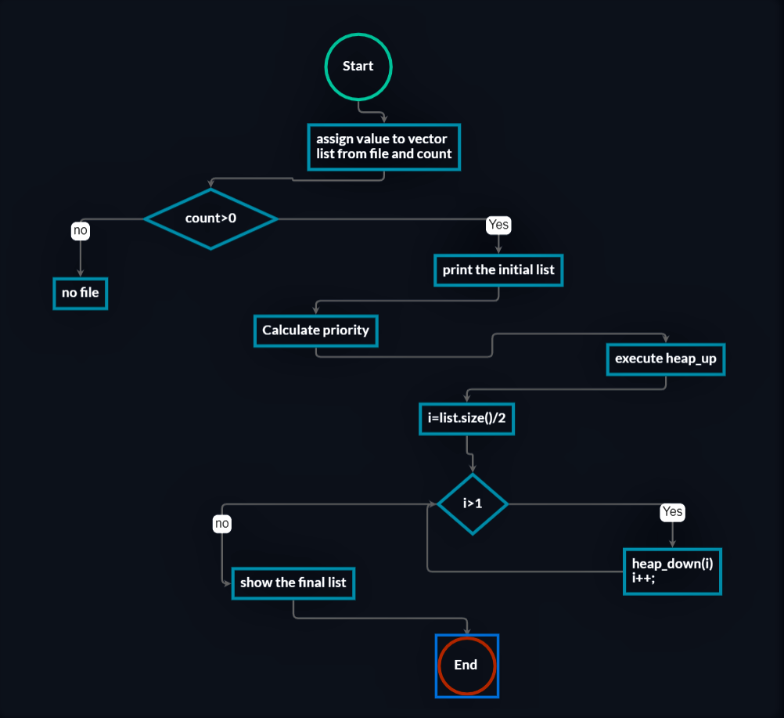

Future work: Our application has some limitations that it takes all the values of the total passenger together. If any new passenger booked flight it won’t show the values’ need to recalculate the whole data for the priority list. We will work on this in future to avoid the recalculation and it will able to take one record and then to show the priority list.
Conclusion: Our ultimate goal is to give a priority list which can satisfy each and everyone. That is why we took many parameters and we need to let the customer know about the rule and regulation that how we calculate the priority list.
We did it just to ensure everyone’s priority. This list will help the customer to make proper decision and hope it would make their travel easy.

